**WHOSE GOT MY BACK! Sponsorship Fundraiser**

I will be wrestling for the Indiana Youth Mat Club during the 2024-25 season and I am reaching out to my biggest fans, friends, family and businesses for sponsorship help. My people make me who I am. The love and support of those around me brings lots of encouragement throughout the year. I am asking you to help sponsor me by displaying your fan support on our Team Shirts. All of your sponsorship money will go directly to helping me be the very best on the mat I can be. Monies will help purchase tournament supplies, equipment, tournament entry fees, wrestling gear, and league fees. You have the option to show your support on the back of a specially designed PERSONALIZED team shirt that will display all of love and encouragement every time I wear it. Here is how you can help-

* For a $10 donation, two names can be added (Mom & Dad or John Smith). **My goal is to have at least 15 names on my warmup shirt.**
  + **Please write NEATLY the name in the NAME column on the next page- 15 CHARACTERS MAX/DONATION**
* For a $25 donation a short phrase **(up to 10 words)** can be added (Have a great year Jimmy! Love Dad). **My goal is to have at least 10 phrases on my warmup shirt.**
  + **Please write NEATLY the phrase in the column on the phrase page**
* If you are part of a business, for a $50 donation, your business logo and name can be added to the back of warmup shirt. **My goal is to have 5 businesses on my warmup shirt.**
  + **Please email to** [**indianayouthmatclub@gmail.com**](mailto:indianayouthmatclub@gmail.com) **the wrestlers name and a logo of the business that is sponsoring them. Please also write NEATLY the name of the business as well ON THE BUSINESS SHEET SO WE CAN CROSS CHECK THIS!**
* For a $100 donation your name and business logo can be printed on the length of the sleeve. **My goal is to fill both sleeves!**

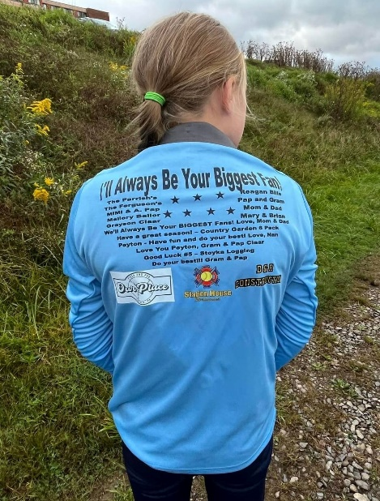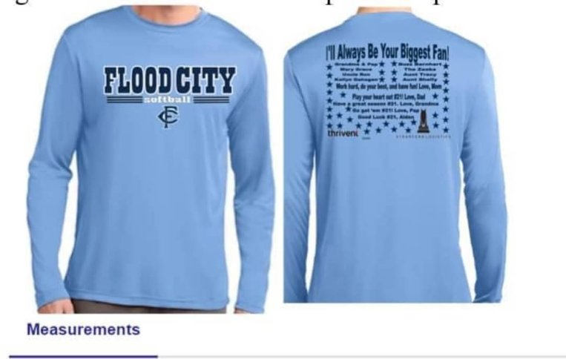

|  |  |  |  |  |  |  |  |  |  |  |  |  |  |  |  |
| --- | --- | --- | --- | --- | --- | --- | --- | --- | --- | --- | --- | --- | --- | --- | --- |
| **Sponsorship** | **Goals** | | | | | | | | | | | | | | |
| **Name- $10** | 1 | 2 | 3 | 4 | 5 | 6 | 7 | 8 | 9 | 10 | 11 | 12 | 13 | 14 | 15 |
| **Phrase- $25** | 1 | 2 | 3 | 4 | 5 | 6 | 7 | 8 | 9 | 10 |  |  |  |  |  |
| **Business-$50** | 1 | 2 | 3 | 4 | 5 |  |  |  |  |  |  |  |  |  |  |
| **Sleeve- $100** | 1 | 2 |  |  |  |  |  |  |  |  |  |  |  |  |  |