**Information about the Keystone League**

The Keystone League is a group of 47 schools in the area that have a wrestling program and have joined to form the Keystone League. During the months of December and January several league matches are held throughout the area. Each school is invited to participate in 6 Keystone SITE MATCHES based on location and number of wrestlers in their program.

* Your child will encounter different groupings of wrestlers at each Keystone. Hopefully!
* Your child will be matched with other children with similar weight, age and skill level for these matches as best as possible. This is not perfect. Sometimes there are not many options. We will do our best to get your child like age/ability level matches.

Wrestlers in **6U, 8U**, and **10U** are required to participate in at least **4** of the 6 Keystone matches to be eligible to wrestle in the Keystone Qualifiers and Tournament of champions held in February.

Wrestlers in **12U** are required to participate in at least **3** of the 6 Keystone matches to be eligible to wrestle in the Keystone Finals Tournament held in February.

The weekly site matches are exhibition style meaning the outcome of the matches are not contingent upon participation in the Keystone Qualifiers at the end of season. Its about improvement and the process of wrestling vs Wins/Losses.

**Keystone Tournament of Champions**

Those participating in the **Keystone** **Tournament of Champions** will be required to weigh-in several days before at a designated weigh-in location.

* To advance to the TOC, ALL wrestlers must participate in the **Keystone Qualifiers** 
  + If weight classes are small <16 wrestlers, your wrestler’s weight class will advance directly to the Keystone Finals
  + to advance to the ***Keystone Finals***, your wrestler must place **1st -4th** in his/her respective bracket
* For this tournament, the ONLY criteria for pairings will be weight and age (not experience nor ability). A true tournament. Weight classes are generally in 5 pound increments. For example, if your child weighs 51 pounds at weigh-ins, he will be required to wrestle as a 55 pounder.
  + period lengths for these matches are the following:
    - **6U** and **8U** 1-1-1
    - **10U** and **12U** 2-1-1
* This is a DOUBLE elimination tournament meaning even if your wrestler loses a match, he/she can win in the consolation bouts and still place **3rd or 4th.**

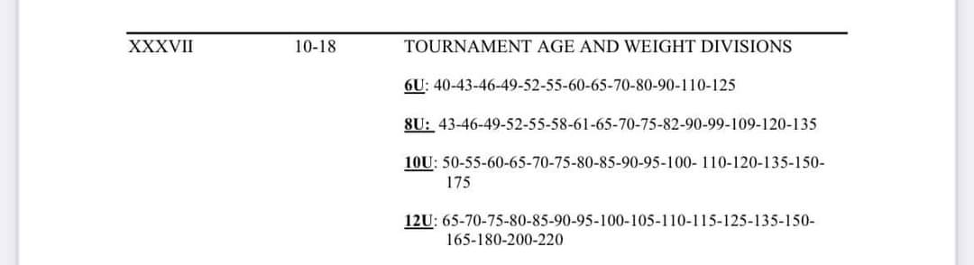

**Teams in the Keystone League**

Albert Gallatin, Apollo, Armstrong, Baldwin, Belle Vernon, Beth Center, Brownsville, Burrell, Charleroi, Connellsville, Derry, Elderton, Elizabeth Forward, Franklin Regional, Frazier, Gateway, Greensburg Salem, Hempfield, Highlands, Indiana, Jefferson Morgan, Kiski, Knoch, Latrobe, Ligonier Valley, Marion Center, McKeesport, Mt Pleasant, Norwin, Penn Hills, Penn Trafford, Plum, Ringgold, River Valley, Saltsburg, Shadyside Boys & Girls Club, South Allegheny, Southmoreland, Thomas Jefferson, Valley, Waynesburg, West Mifflin, Westinghouse, Woodland Hills,Yough